In your own words, explain what diabetic retinopathy is and why it is a serious public health problem. Think about: Who gets it? What does it do to the eye? What happens if it is not caught in time? Why can't we just send every patient to a specialist?
Over 500 million people live with diabetes. One of those complications is diabetic retinopathy, a condition where high blood sugar slowly damages the tiny blood vessels in the back of your eye (the retina). If caught early, it can be treated. If missed, it leads to permanent blindness. There are not enough eye specialists (ophthalmologists) in the world especially in rural areas and developing countries to screen every diabetic patient every year. That is where Artificial Intelligence comes in.

AI needs to LEARN before it can diagnose. Explain, in simple terms, what 'training data' is and why it was important that 54 ophthalmologists labeled 128,000 photos for Google's AI. What would happen if the AI was trained only on photos from one country or one ethnic group?
Training data is data (labeled or unlabeled) that is given to the machine learning model for it to discover patterns between the inputs and outputs and decision-make. If the data fed to the model doesn’t represent everyone, the model becomes biased. Example: There’s a bias in AI because the model was trained only on light-skinned retinas and might miss patterns in darker-pigmented retinas.

Google's retina AI achieved 90% sensitivity and 98% specificity in trials. Using the Cheat Sheet to understand these terms, explain in plain English what these numbers mean for a patient. Is 90% sensitivity good enough? What happens to the 10% of cases it misses?
Missing 10% of cases means 1 in 10 sick patients gets a false positive. That's why human oversight still matters.

The AI was deployed in Thailand's rural clinics where no eye doctor was available. Describe TWO specific benefits this created for patients and ONE challenge or risk that came with using AI in this setting. Consider: privacy, equipment availability, internet access, patient trust.
One challenge that comes with using AI in this setting is having no HITL (human in the loop) since there’s no ophthalmologists to review the retinal photographs that get flagged by the AI and make the final decision. Two benefits that come with using AI in this setting created for patients:
- Early detection and blindness prevention since AI can analyze images and detect signs of diabetic retinopathy like microaneurysms that the human eye would miss before the symptoms are severe.
- More access to specialized care since patients can perform eye exams in local clinics instead of having to travel to urban hospitals. It’s more convenient.

Create a simple comparison: list TWO things the AI can do BETTER than a human doctor in this scenario, and TWO things the human doctor can do that the AI CANNOT. Conclude: do you think this AI should be used without any doctor involvement? Why or why not?
Things AI can do better than human doctors | Things AI cannot do better than human doctors
Detect microaneurysms in retinal photographs that human doctors might miss early | Provide emotional support and feel empathic
Scan thousands of retinal photographs at a time | Consider the whole patient

AI should not be used without any ophthalmologist involvement. Even though it can pick details and patterns that ophthalmologists won’t notice plus scan thousands of images at a time, human doctors should be involved because they can consider the whole patient and ensure ethical decisions are made.
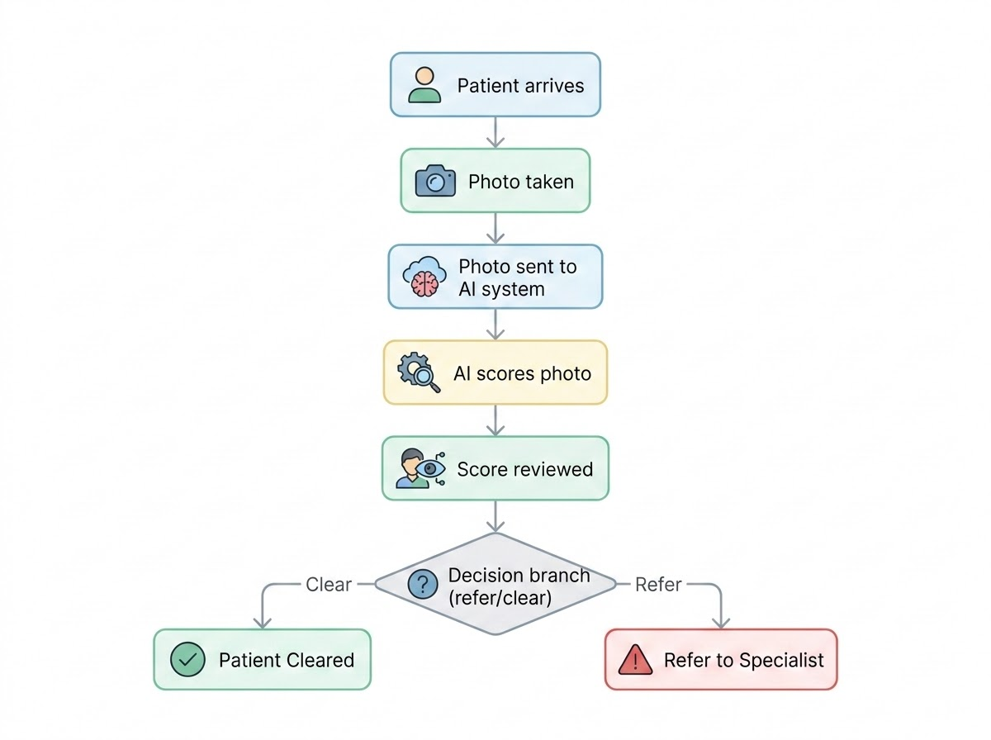

Privacy Concern: The AI needs photographs of patients' eyes to work. These photographs are medical data. Who should own this data — the patient, the hospital, the AI company (Google), or the government? What could go wrong if this data was misused?
Retinal photographs are medical data, so they should belong to the patient, because it is their body and health info. AI needs these photos to work, but that also means the images could be misused if not protected. If a company or government controlled the data, it could be used for purposes patients never agreed to: insurance decisions, surveillance, or selling health profiles. Since the retina is unique to each person, losing control of this data could be as serious as losing a fingerprint or DNA record. Patients should have the right to decide who stores their images, how long they are kept, and whether they can be used to train future AI systems.

The Equity Question: Currently, the AI works best on patients whose data it was trained on. If an AI company trains mostly on patients from wealthy countries, the AI may be less accurate for patients in Africa or Asia. Is this fair? Whose responsibility is it to fix this — the company, the government, or doctors?
AI works best on the types of patients it was trained on (“Bias happens when training data doesn’t represent everyone”). If an AI company trains mostly on patients from wealthy countries, it is unfair for people in Africa or Asia to receive less accurate diagnoses. Healthcare should not depend on where someone lives or what their skin tone looks like. I believe the responsibility is shared:
- AI companies must build diverse training datasets.
- Governments should require fairness testing before approving medical AI.
- Doctors should report when the AI performs poorly on certain groups.
If all three work together, the AI becomes safer and more equitable for everyone.

Trust and Transparency: Imagine you are a patient in a rural clinic. A nurse tells you: 'A computer analyzes your eye photo and says you don't have disease — you can go home.' How would you feel? What information would you want to know before trusting this result?
If a nurse told me, “A computer analyzed your eye photo and says you don’t have disease,” I would feel a mix of relief and uncertainty. I would want to know how accurate the AI is, whether a doctor will double check the result, and what signs the AI looked for. Since AI can miss 10% of real cases, I would want reassurance that someone will review my photo if anything looks borderline. I would also want to know how my data is stored and whether my photo will be used for anything besides my diagnosis. Clear explanations would help me trust the system more.

Explain in your own words why a regular TV weather forecast is NOT useful enough for a farmer like the Torres family. What specific information does a farmer need that a general forecast doesn't provide? Give at least THREE specific examples of farming decisions that depend on precise local weather data.
Regular TV weather forecasts are not useful enough for the Torres family because they only give broad regional predictions like “60% chance of rain in the Houston area.” Farmers need hyperlocal information for their exact fields, not general city-wide forecasts. The Torres family must know if it will rain on their specific 400 acres, not somewhere in the region. Three farming decisions that require precise local weather data:
- Planting dates: Planting too early risks frost killing the seeds, and the assignment notes that “too early = frost kills the seeds”
- Irrigation timing: Too much water causes disease, too little causes drought stress.
- Harvest timing: “One unexpected rainstorm on ripe wheat can destroy an entire year’s income”

AI weather systems use many different data sources. Name and briefly explain at least FOUR types of data that an AI farm weather system collects and uses. For each, explain WHY that specific data type is useful for a wheat farmer in West Texas.
AI weather systems combine many data sources to create hyperlocal predictions “for YOUR specific field - hour by hour.” Four key data types:
- Soil moisture sensors: These measure how much water is in the soil. The cheat sheet explains that soil moisture tells farmers whether irrigation is needed.
- Weather satellites: Satellites measure cloud cover and soil conditions “across thousands of farms simultaneously.”
- Historical weather records: The AI studies “30-50 years of weather history” to learn frost patterns and rainfall cycles.
- Temperature and humidity sensors: These real-time sensors help predict frost, drought, and disease risk.
Each data type helps the Torres family make better decisions about planting, irrigation, and frost protection.
The Torres family pays $1,500/year for the AI weather service. Last year, they lost $54,000 (30% of $180,000 crop value) because a frost was missed. If the AI weather system could predict late frosts with 85% accuracy and they could protect the crop (e.g., with wind machines or timing their planting differently): How much money could they potentially save? Is $1,500/year a good investment? Show your calculation.
Last year, the Torres family lost $54,000 because a frost was missed. The assignment states that a late frost “can kill crops worth $180,000 in a single night”.
If AI prevents 85% of frost damage:
0.85 × 54,000 = 45,900
Savings after subtracting the $1,500 subscription:
45,900 − 1,500 = 44,400
Conclusion: Saving $44,400 makes the $1,500 AI subscription an excellent investment.

No AI system is 100% accurate. Describe TWO scenarios where the AI weather prediction could be WRONG and explain the consequences for the Torres family in each case. Then explain why human judgment (the farmer's experience and local knowledge) should still play a role even when using AI.
AI is powerful, but “no AI system is 100% accurate.” Two scenarios:

Scenario A - False Frost Alert (False Positive)
The AI predicts frost, but none occurs. The Torres family might run wind machines all night, wasting fuel and money. The cheat sheet explains that a false alarm means the farmer “takes protective action unnecessarily.”

Scenario B - Missed Frost (False Negative)
The AI predicts a clear night, but frost arrives. This could destroy tens of thousands of dollars in wheat, since a frost “can destroy an entire wheat crop in a single night”. Mr. Torres has decades of experience reading the land. His local knowledge noticing cattle behavior, soil smell, or wind shifts can catch subtle signs the AI might miss.

The Ogallala Aquifer (which the Torres family uses for irrigation) is being depleted. Explain how AI weather prediction could help the Torres family use significantly less water for irrigation. Give at least TWO specific examples of how a weather AI would change their irrigation decisions. Research: how much water does traditional vs. AI-guided irrigation typically save?
The Ogallala Aquifer is “running out”, so saving water is critical. AI helps reduce irrigation by:
- Skipping irrigation when rain is predicted: The quick reference table says if rain is coming, the farmer should “skip irrigation this week.”
- Using soil moisture data: If sensors show moisture is still high, irrigation is unnecessary.
Studies in the assignment note that precision irrigation can reduce water use by 30-50%, saving tens of thousands of gallons per season.

Using the scenario below, create a 14-day farm planning table for the Torres family. Imagine the AI has given them the following forecast for the first two weeks of April (planting season): Days 1-3: Sunny, 24C, no rain. Days 4-6: Cold front arriving, temperature dropping to 5C, frost risk HIGH. Days 7-9: 60% chance of rain, moderate. Days 10-12: Clear, 22C, wind 20km/h. Days 13-14: Possible hail. For each period, write what farming action the Torres family should take and WHY the AI data changes their decision.
Date Range | AI Forecast | Recommended Action & Reason
Days 1–3 | Sunny, 24°C, no rain | Begin planting. The assignment notes that optimal planting windows matter because planting too late reduces yield (p. 9).
Days 4–6 | Cold front, 5°C, HIGH frost risk | Pause planting and protect young plants. Frost can “destroy an entire wheat crop in a single night” (p. 9).
Days 7–9 | 60% chance of moderate rain | Skip irrigation. The quick reference table says rain + high soil moisture means “skip irrigation this week” (p. 10).
Days 10–12 | Clear, 22°C, windy | Resume planting and field work. Wind helps dry soil and prevents disease.
Days 13–14 | Possible hail | Delay harvest or protect equipment. Hail can damage crops and machinery.

Food Security and Climate Change: Climate change is making weather MORE unpredictable — more extreme droughts, unexpected frosts, heavier storms. How does AI weather prediction become MORE important (not less) as climate change continues? Give one specific example of how AI could help a farmer adapt to a climate change impact.
Climate change brings “more extreme droughts, unexpected frosts, heavier storms”. AI becomes more important because it helps farmers adapt to unpredictable weather. For example, if climate change increases sudden frost events, AI can warn farmers days in advance so they can protect crops and avoid massive losses.

The Digital Divide in Farming: The AI weather service costs $1,500/year. A large corporate farm with 50,000 acres finds this very affordable. A smallholder farmer in rural Kenya with 2 acres finds it completely unaffordable. What are the ethical implications of AI making some farmers much more competitive while others cannot access it? What could be done to make AI weather tools accessible to small farmers globally?
AI weather tools cost $1,500/year, which is easy for a large farm but impossible for a small farmer in Kenya. This creates unfair advantages, wealthy farms become more competitive while small farmers fall behind. To fix this, governments and NGOs could subsidize AI tools, or companies could offer low-cost versions for small farms.

Farmer Knowledge vs. AI: A third-generation farmer like Mr. Torres has decades of experience reading the land — he notices things like how his cattle behave before a storm, or how the dust smells when rain is coming. Do you think AI should REPLACE this kind of traditional farming knowledge, or COMPLEMENT it? Give a specific example of when human experience would catch something the AI might miss.
AI should complement, not replace, traditional farming knowledge. Mr. Torres notices subtle signs like how cattle behave before storms that AI cannot detect. Microclimates can differ even within one mile, and human experience helps interpret these local quirks.

Ting, D. S. W., et al. “Development and Validation of a Deep Learning System for Diabetic Retinopathy and Related Eye Diseases Using Retinal Images from Multiethnic Populations with Diabetes.” JAMA, vol. 318, no. 22, 2017, pp. 2211–2223.
Beede, E., et al. “A Human‑Centered Evaluation of a Deep Learning System Deployed in Clinics for the Detection of Diabetic Retinopathy.” Proceedings of the 2020 CHI Conference on Human Factors in Computing Systems, ACM, 2020.

